Intranasal fentanyl delivery procedure

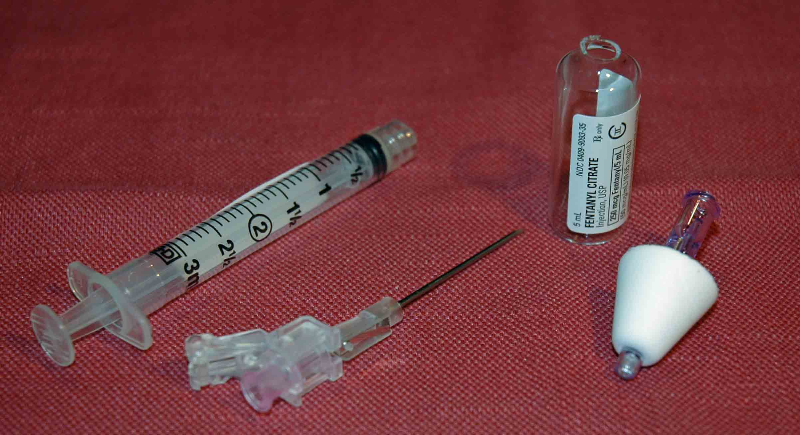
Intranasal fentanyl
delivery Materials:

- 1 ml or 3 ml syringe
- Needle to draw up the fentanyl
- Atomizer
- Vial of fentanyl

Procedure:
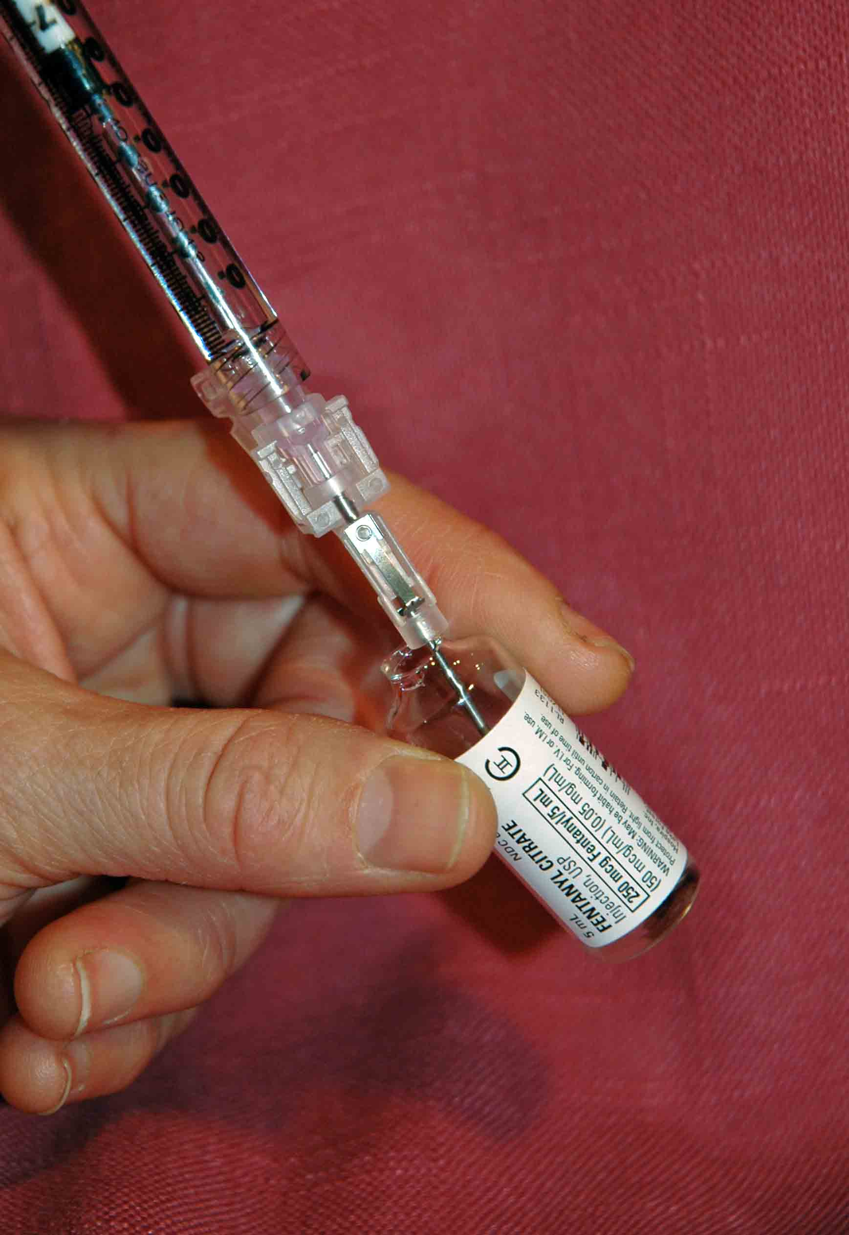
- Aspirate the proper volume/dose of fentanyl per the weight based dosing protocol of the study

- Twist off/remove the syringe from the needle/needleless device

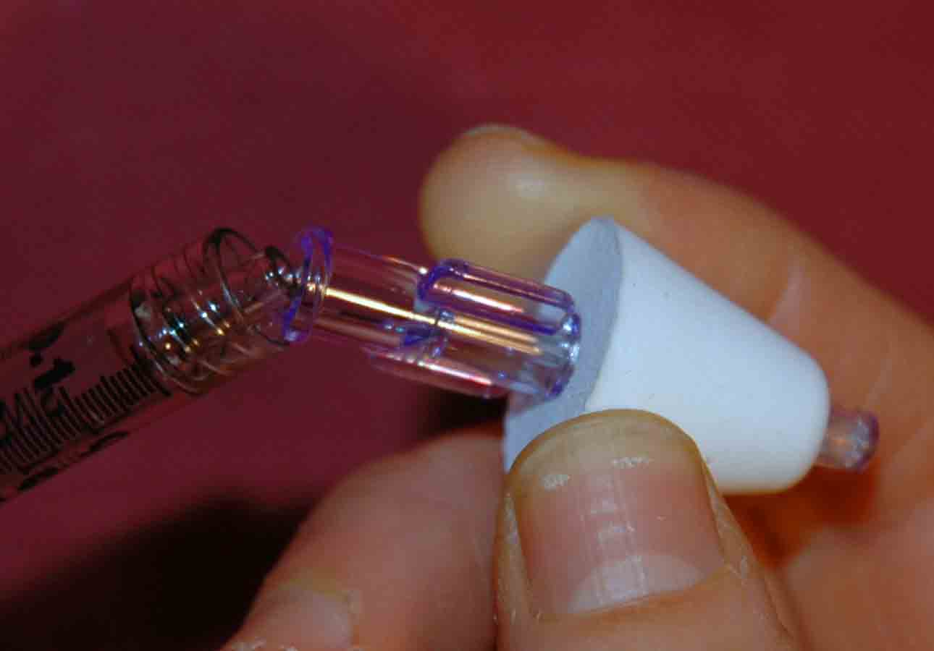
- Attach the atomizer tip via Luer lock mechanism – it twists into place.

- Using your free hand to hold the crown of the head stable, place the tip of the atomizer snugly against the nostril aiming slightly up and outward (towards the top of the ipsilateral ear).
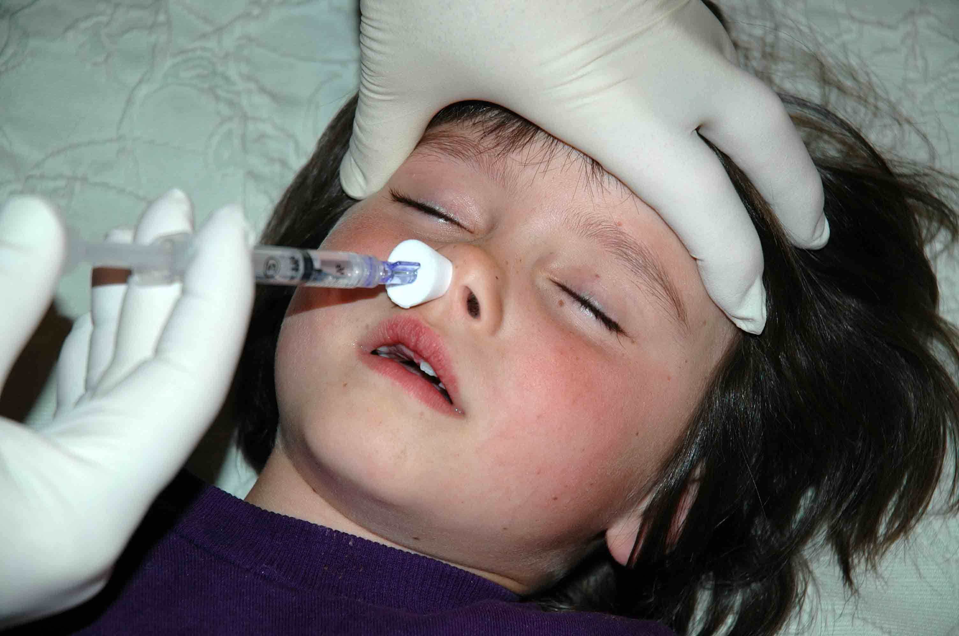

- Briskly compress the syringe plunger to deliver approximately half of the medication into the nostril.

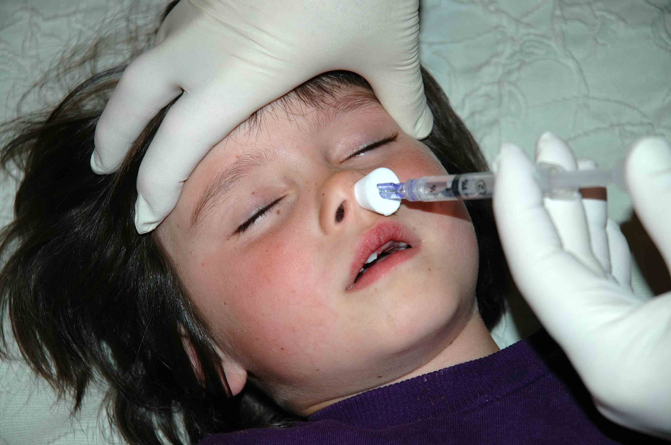
- Move the device over to the opposite nostril and briskly administer the remaining half of the medication into that nostril.

- Consider using a pulse oximeter for 45-60 minutes following medication delivery due to the rare but possible risk of respiratory depression from an opiate.

