Intranasal sufentanil delivery procedure

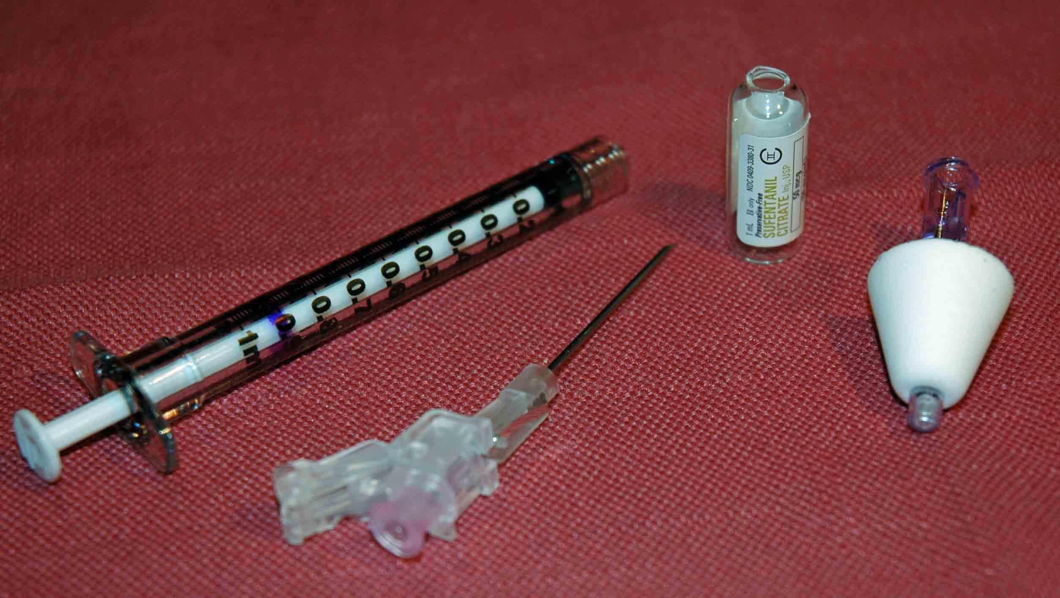
Intranasal sufentanil
delivery Materials:

- 1 ml syringe (two syringe if more than 1 ml used, or reuse the single syringe)
- Needle to draw up the sufentanil
- Atomizer
- 50 mcg vial of sufentanil (use two vials depending on weight based dose/volume required)
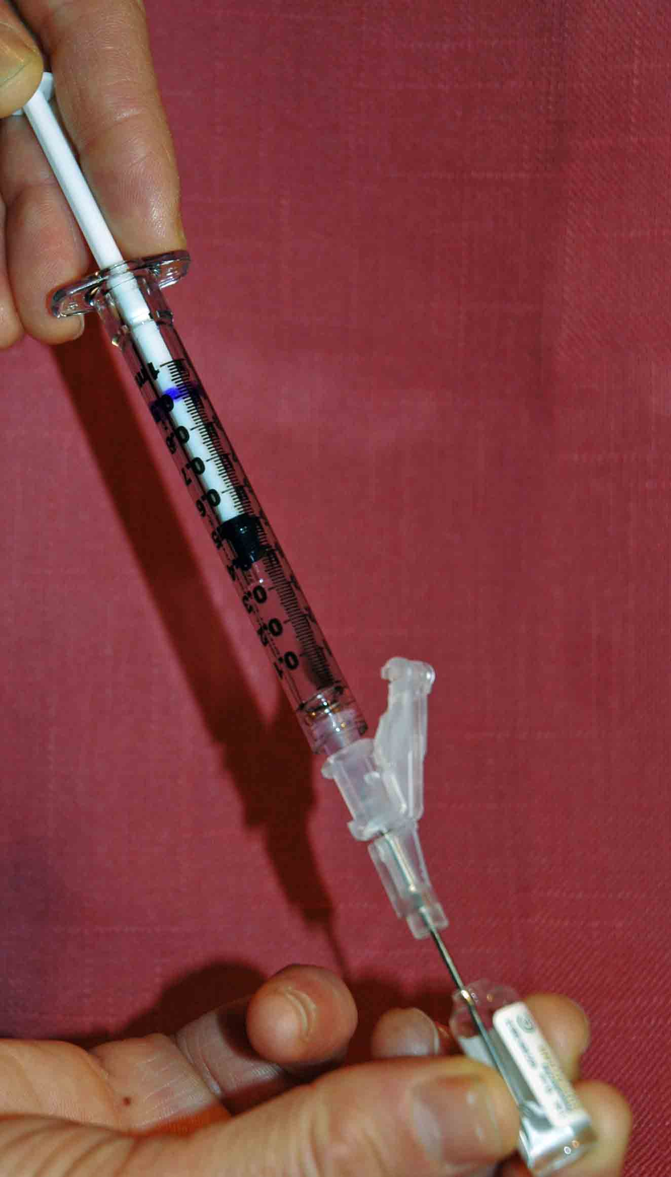
Procedure:

- Aspirate the proper volume/dose of sufentanil per the weight based dosing protocol of the study

- Twist off/remove the syringe from the needle/needleless device

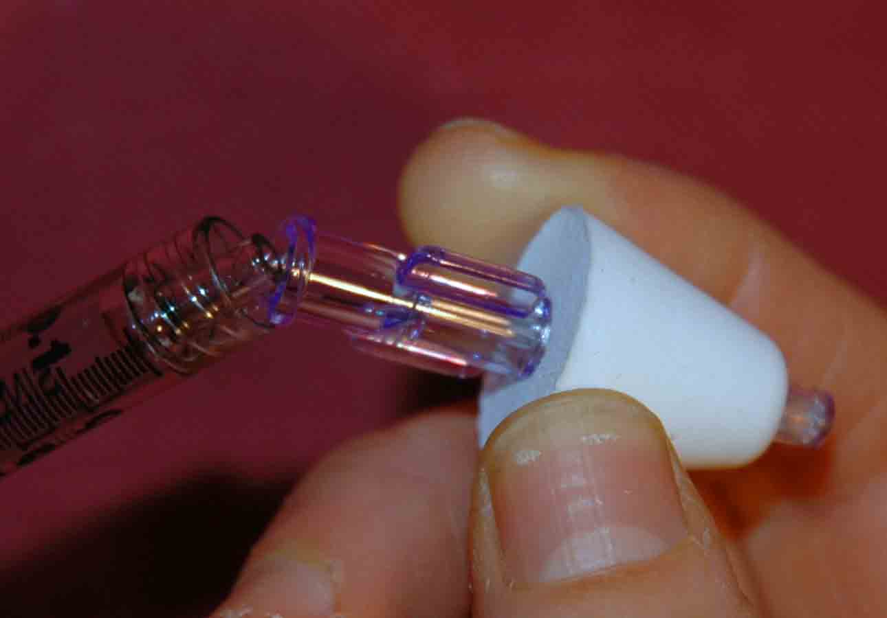
- Attach the atomizer tip via Luer lock mechanism – it twists into place.

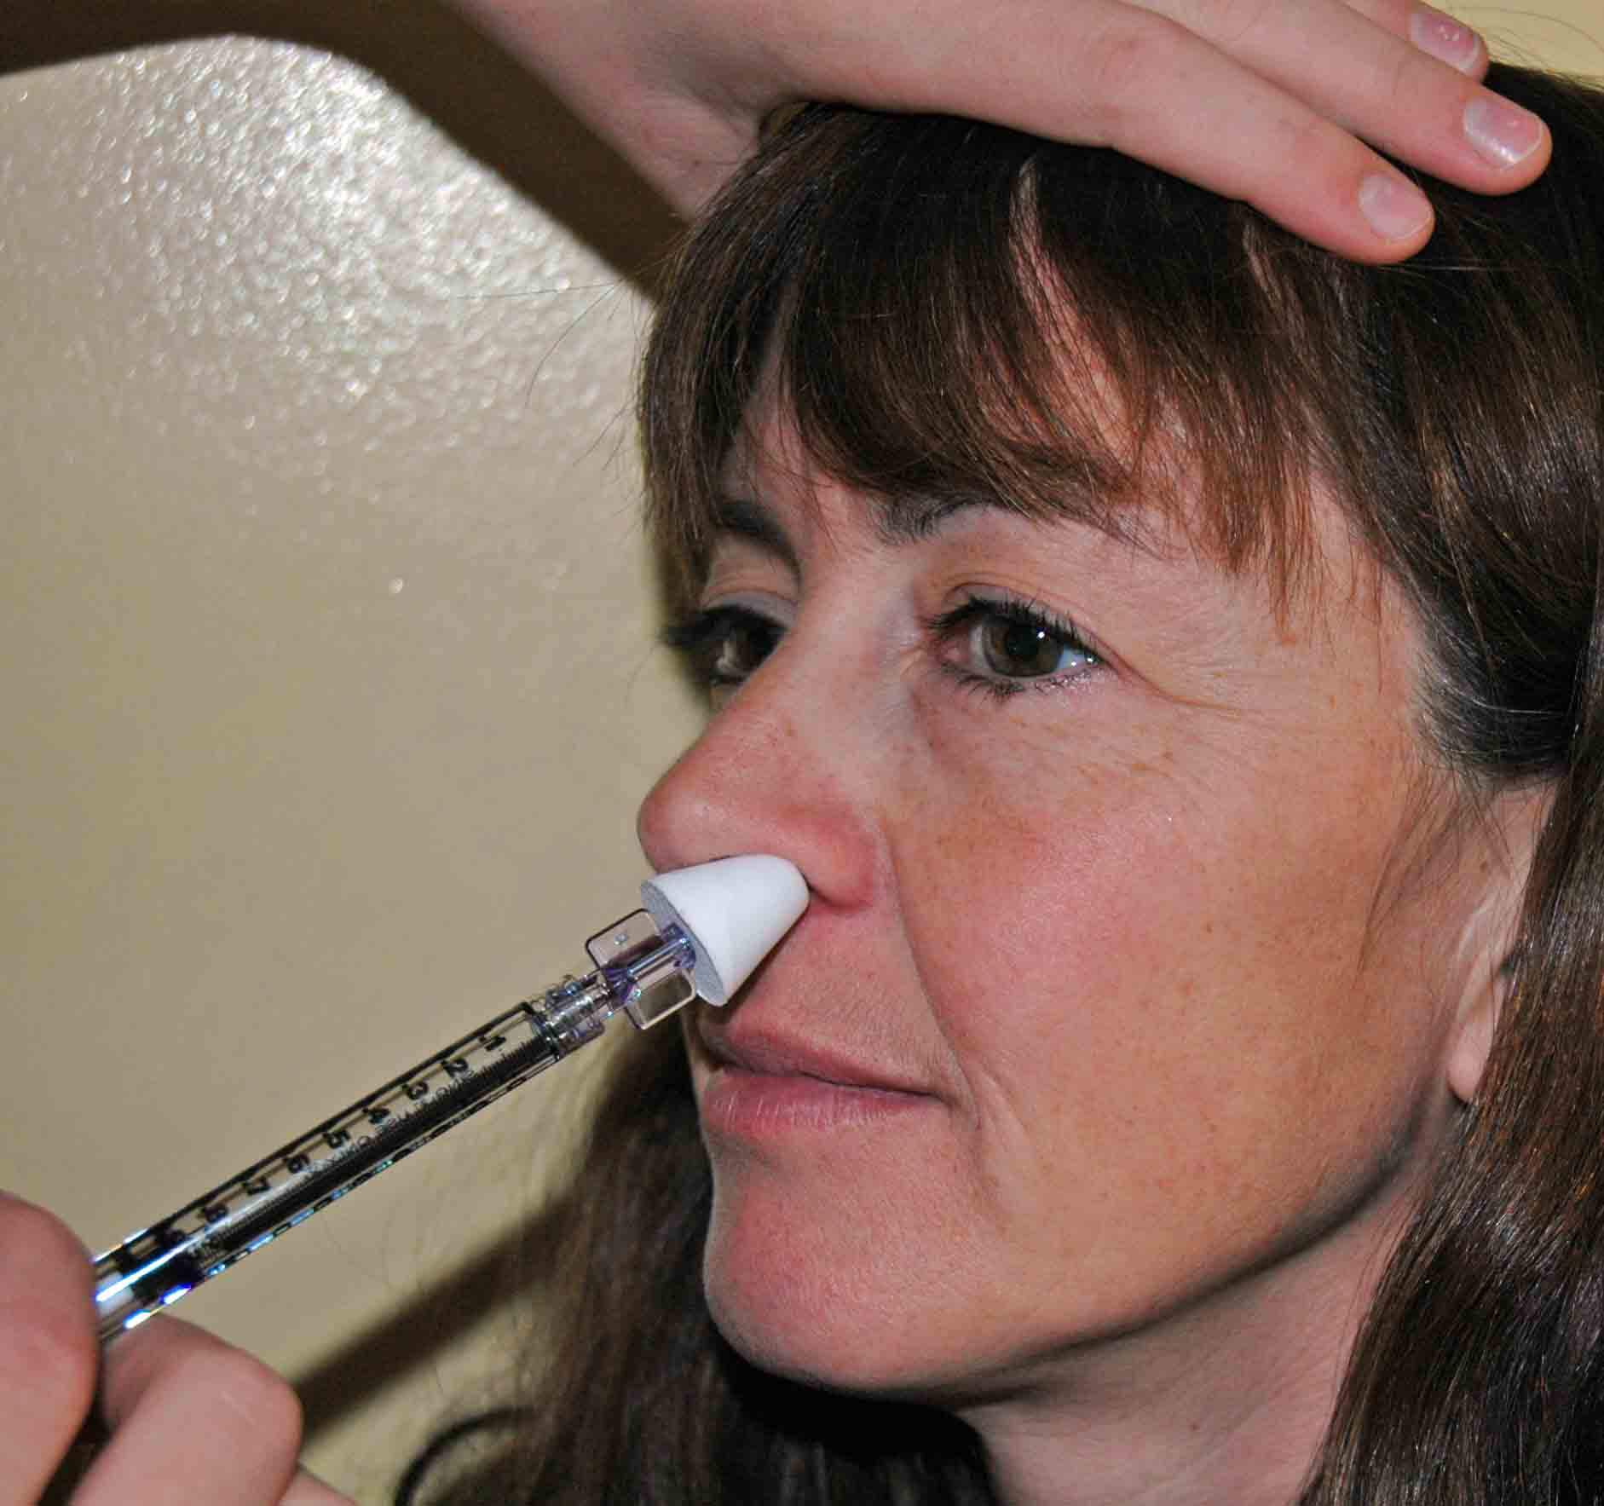
- Using your free hand to hold the crown of the head stable, place the tip of the atomizer snugly against the nostril aiming slightly up and outward (towards the top of the ipsilateral ear).

- Briskly compress the syringe plunger to deliver approximately half of the medication into the nostril.

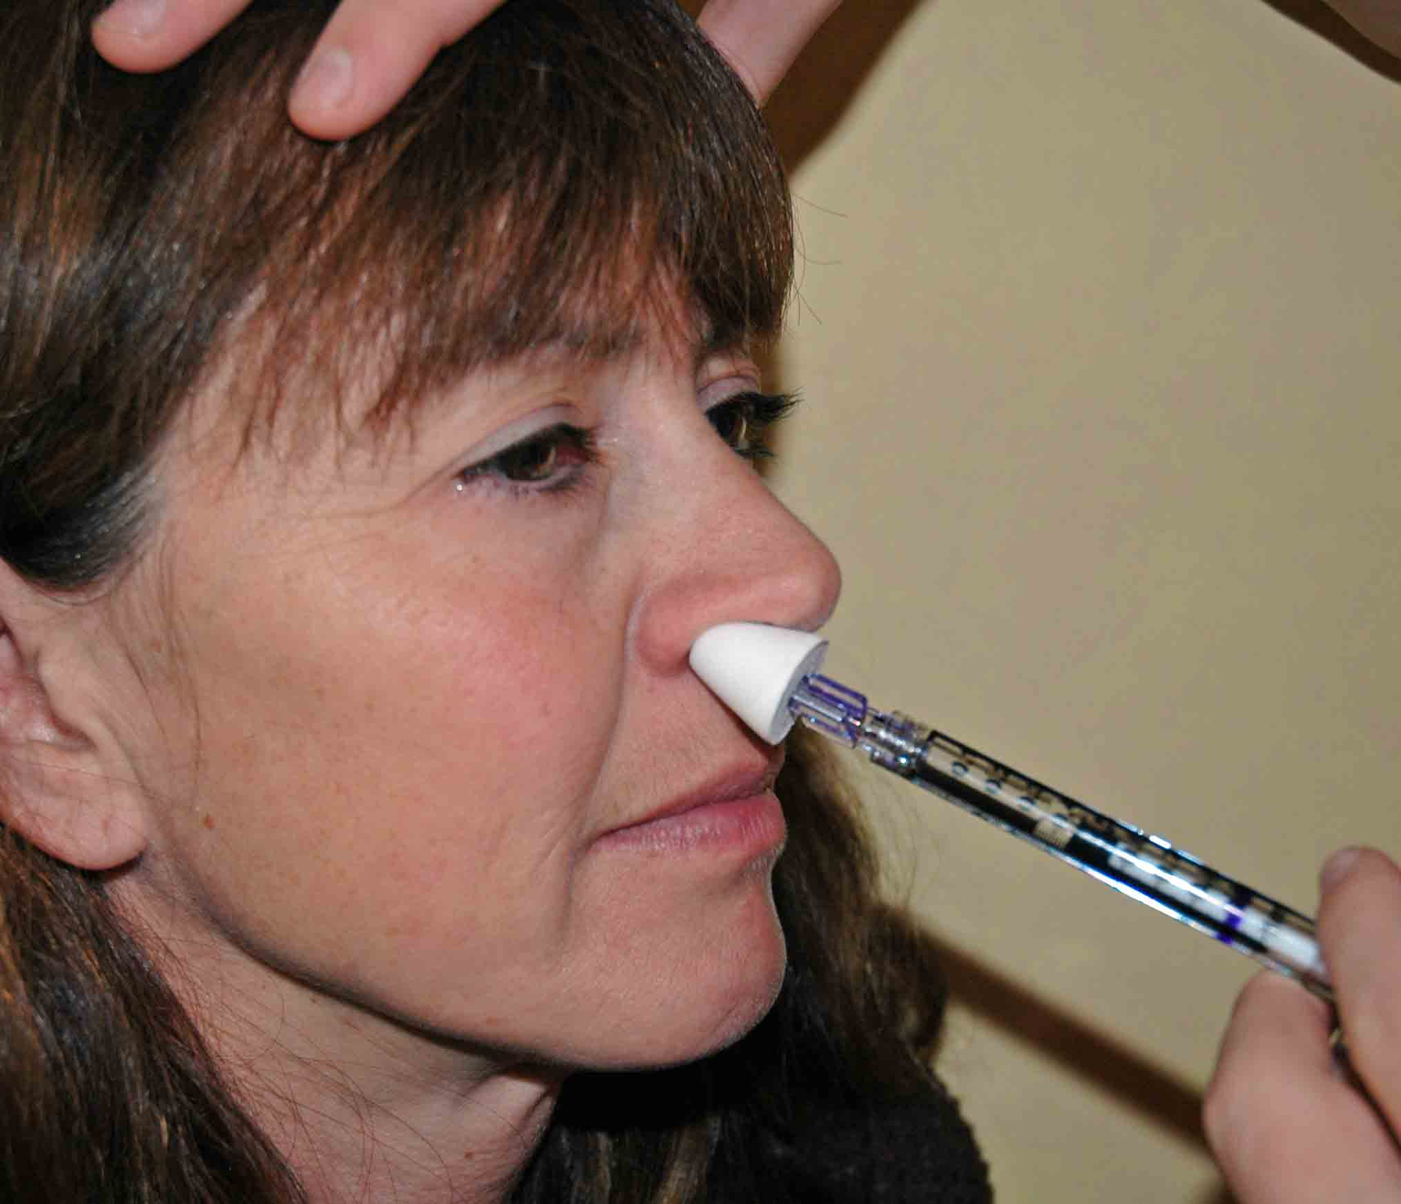
- Move the device over to the opposite nostril and briskly administer the remaining half of the medication into that nostril.

- The patient must be on a pulse oximeter during this entire procedure and for 45-60 minutes following medication delivery due to risk of respiratory depression from this powerful drug.

